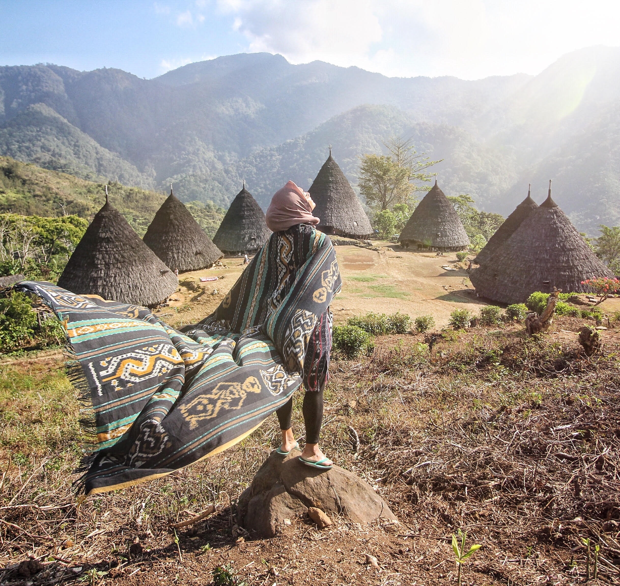
WELCOME TO FLORES
EXPLORE AND ENJOY FLORES

Friendly Customer Services : Call/Whatsapp
+6282332664599 with Ronald

KELIMUTU - WAE REBO (FLORES TOUR START ENDE)
5 DAYS 4 NIGHTS

DAY 1 / TRANSFER IN (-)
You will be picked up at the Meeting Point (Ende Airport) by our professional team. When you arrive, we will immediately go to the Moni area to spend the night and rest.
*If the arrival time is morning, afternoon or evening and time permits, we can take the time to visit several nice places in Ende such as Bung Karno's Exile Place, Suspension Bridge, Ende Market, Datu Soko Rice Fields to shop for typical goods, etc.

DAY 2 / KELIMUTU – FLORES TOUR (B)
Today we will wake up early at 04.00 to go to Kelimutu Lake. Upon arrival we will trek on a gentle road for approximately 30 minutes to the peak of Kelimutu to enjoy the sunrise and the landscape of this 3-colored lake. When finished, we will return to the hotel to clean up. Next we will continue our journey to Blue Stone Beach. After that we headed to Soa (Natural Hot Springs) and rushed to the hotel in Bajawa. Rest.

DAY 3 / WAE REBO TOUR (B)
Morning Call, we are waiting for Sunrise at Wolobobo Hill. Return to the hotel for breakfast and clean up. Preparation for going to Manggarai by taking the time to visit the Bena Traditional Village. Here you can communicate with local people and try Siri Pinang (a typical NTT food which is believed to be good for dental health in the community). Once finished, we will visit and see the process of making Traditional Flores Wine and after that we can fill our time by visiting Cepiwatu Beach. Until evening we will spend the night in the Ruteng area.

DAY 4 / WAE REBO TOUR (B,D)
Breakfast at Hotel. In the morning at 07.00 WITA. We will immediately go to Wae Rebo by taking the time to visit the Spider Web Rice Field. Upon arrival we will take a short break in Denge Village then you will start walking for approximately 2 hours to arrive at Wae Rebo Village accompanied by a Tour Guide and Porter. Upon arrival you will take part in a residence permit procession in the traditional village by the tribal chief and you will be given Wae Rebo Coffee. Free event to relax and interact with residents. Dinner together with a traditional Wae Rebo menu and free program.

DAY 5 / WAE REBO TOUR – TRANSFER TO LABUAN BAJO (B)
After drinking morning coffee, you can capture photos of the sunrise and local residents, chat and then have breakfast until it's time to leave Wae Rebo *We do not limit the time/according to mutual agreement. Then return to Denge Village. Until it's time to leave Wae Rebo in the afternoon to head to the Drop Point in Labuan Bajo.

PRICES :
2 Paxs | 3 Paxs | 4 Paxs | 5 Paxs | 6 Paxs
IDR 4.995.000,-/pax | IDR 4.475.000,-/pax | IDR 3.962.500,-/pax | IDR 3.375.000,-/pax | IDR 2.980.000,-/pax

FACILITIES :
- Standard Tourism Transportation according to total of participants (private tour)
- Accommodation at the Wae Rebo Traditional House (Mbaru Niang) for 1 night
- 3 star hotel accommodation for 1 night in Bajawa
- 3 star hotel accommodation for 1 night in Ruteng
- 2 star hotel accommodation for 1 night in Moni
- Customary levy fees (Waelu'u)
- Entrance tickets to tourist attractions
- 2 x Meals at Wae Rebo Village
- 2 x Wae Rebo specialty Coffee Break
- Mineral water
- Friendly and professional drivers
- Local Tour Guide and Porter
- First aid

TERMS AND CONDITIONS :
- Prices may change if there are changes in component prices that are outside standard tolerances, according to the travel concept and allocation of the number of participants.
- Expenses outside the tour package components are the responsibility of the tour participants.
- Prices do not include *opt (optional tour), or additional objects.
- Price does not include tipping tour guide/porter (voluntary)
- Price does not include Wae Rebo Tour Motorbike Taxi. Prices range from IDR 80,000 for round trip *That is optional if you feel you need it
- Prices do not include excess fuel for non-reasonable pick-ups.

WAE REBO – KELIMUTU (FLORES TOUR START LABUAN BAJO)
4 HARI 3 MALAM

DAY 1 / TRANSFER WAE REBO TOUR (D)
In the morning at 08.00 WITA. You will be picked up at the Meeting Point (Labuan Bajo). We will go straight to Wae Rebo. Upon arrival we will take a short break in Denge Village then you will start walking for approximately 2 hours to arrive at Wae Rebo Village accompanied by a Tour Guide and Porter. Upon arrival you will take part in a residence permit procession in the traditional village by the tribal chief and you will be given Wae Rebo Coffee. Free event to relax and interact with residents. Dinner together with a traditional Wae Rebo menu and free program.

DAY 2 / WAE REBO TOUR – TRANSFER TO RUTENG (B)
After drinking morning coffee, you can capture photos of the sunrise and local residents, chat and then have breakfast until it's time to leave Wae Rebo *We do not limit the time/according to mutual agreement. Then return to Denge Village. After that, you will be invited to visit the Spider Web Rice Field. Until it was time to leave Wae Rebo in the afternoon to go to Denge Village and rush to the hotel in the Ruteng area.

DAY 3 / FLORES FULLDAY TOUR (-)
Good Morning. We will pick you up at your Ruteng hotel and immediately start your Flores tour. First we will visit the Malanage Hot Springs and take photos behind Mount Inerie. Until we are satisfied, we will continue our journey to Bena Traditional Village. Here you can communicate with local people and try Siri Pinang (a typical NTT food which is believed to be good for dental health in the community). Next we will continue our journey to Penggajawa Beach. Until it was finished we immediately rushed to Moni to spend the night.

DAY 4 / KELIMUTU - TRANSFER OUT (-)
Today we will wake up early at 04.00 to rush to Kelimutu Lake. Upon arrival we will trek on a gentle road for approximately 30 minutes to the peak of Kelimutu to enjoy the sunrise and the landscape of this 3 colored lake. When finished, we will return to the hotel to clean up and prepare to go to Ende City and visit several good places in Ende such as Bung Karno's Exile Place, Ende Market for shopping. Until the time, you will be taken to the Drop Point (Ende Airport). The trip was completed satisfactorily with us.

PRICES :
2 Pax | 3 Pax | 4 Pax | 5 Pax | 6 Pax
IDR 3.895.000,-/pax | IDR 3.375.000,-/pax | IDR 2.962.500,-/pax | IDR 2.575.000,-/pax | IDR 2.290.000,-/pax

FACILITIES :
- Standard Tourism Transportation according to total of participants (private tour)
- Accommodation at the Wae Rebo Traditional House (Mbaru Niang) for 1 night
- 3 star hotel accommodation for 1 night in Ruteng
- 2 star hotel accommodation for 1 night in Moni
- Customary levy fees (Waelu'u)
- Entrance tickets to tourist attractions
- 2 x Meals at Wae Rebo Village
- 2 x Wae Rebo specialty Coffee Break
- Mineral water
- Friendly and professional drivers
- Local Tour Guide and Porter
- First aid

TERMS AND CONDITIONS :
- Prices may change if there are changes in component prices that are outside standard tolerances, according to the travel concept and allocation of the number of participants.
- Expenses outside the tour package components are the responsibility of the tour participants.
- Prices do not include *opt (optional tour), or additional objects.
- Price does not include tipping tour guide/porter (voluntary)
- Price does not include Wae Rebo Tour Motorbike Taxi. Prices range from IDR 80,000 for round trip *That is optional if you feel you need it
- Prices do not include excess fuel for non-reasonable pick-ups.

DANAU KELIMUTU ONEDAY TOUR

DAY 1 / KELIMUTU - ENDE FULLDAY TOUR (-)
GOOD MORNING. We will pick you up at the Meeting Point (Hotel in the Ende/Moni area), in the morning at 03.00 to go to Kelimutu Lake. Upon arrival we will trek on a gentle road for approximately 30 minutes to the peak of Kelimutu to enjoy the sunrise and the landscape of this 3-colored lake. After finishing we will go to the Wologai Traditional House and Murundao Waterfall. Once finished we will be taken to the Drop Point (Ende Hotel/Airport). The trip was completed satisfactorily with us.

OPEN TRIP PRICES ‘EVERYDAY DEPARTURE’ :
IDR 1.100.000,-/pax

PRIVATE TRIP PRICES :
2 Pax | 3 Pax | 4 Pax | 5 Pax | 6 Pax
IDR 600.000,-/pax | IDR 530.000,-/pax | IDR 480.000,-/pax | IDR 440.000,-/pax | IDR 390.000,-/pax

FACILITIES :
- Standard Tourism Transportation according to total of participants
- Entrance tickets to tourist attractions
- Mineral water
- Friendly and professional drivers
- Local Tour Guide
- First aid

TERMS AND CONDITIONS :
- Prices may change if there are changes in component prices that are outside standard tolerances, according to the travel concept and allocation of the number of participants.
- Expenses outside the tour package components are the responsibility of the tour participants.
- Prices do not include *opt (optional tour), or additional objects.
- Price does not include tipping tour guide/porter (voluntary)
- Prices do not include excess fuel for non-reasonable pick-ups.

