KOMODO DIVING (ENGLISH)
ONEDAY TOUR

Dive Program (DAILY DEPARTURE) this is not only for professional divers, but can also for beginners or tourists who are just curious to try to directly enjoy the beauty of Indonesia's underwater. RIGHT ONCE you choose the Komodo Islands. For one full day you can see the diversity of marine life directly up close accompanied by the Dive Masters. The Komodo Islands are one of the best parts of the Coral Triangle which is famous throughout the World, especially for Dive activities lovers.

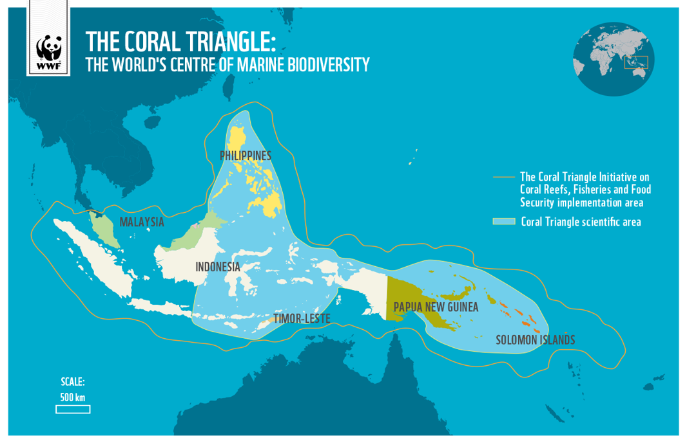
“The Coral Triangle, the global centre of marine biodiversity, is a 6 million km² area spanning Indonesia, Malaysia, the Philippines, Papua New Guinea, Timor Leste and the Solomon Islands.
Within this nursery of the seas live 76% of the world’s coral species, 6 of the world’s 7 marine turtle species, and at least 2,228 reef fish species.
” – WWF (World Wild Life.org)

KOMODO NATIONAL PARK DIVE SPOT (DIVE POINT)
MANTA POINT – SEBAYUR – MAUAN – CRYSTAL ROCK – CASTEL ROCK – COULDRON – PENGAH – WAINILU – KOMODO TREKKING (OPTIONAL)
* Dive Point above can not only be chosen but also depends on the level of ability of participants.

PRICES :
TRY DIVE / Beginner level FUN DIVE / Certified
IDR. 2.700.000,-/pax/day for 2 times (PUBLISH) IDR. 2.500.000,-/pax/day for 2 times (PUBLISH)
AGENT LESS 10% from Publish Price AGENT LESS 10% from Publish Price

*Daily Departure
*Minimum 2 paxs for register

FACILITIES :
- Dive Boat oneday (Sharing)
- Diving Program
- Dive gear (BCD, Regulator, Wetsuit, Masker, Fin), Tank and Weight
- Cruise Director and Ship Crew
- Master Dive/Instructur (1 Dive Master for 4 paxs)
- 1 x Meal
- Coffee Tea unlimited
- Snack
- Air Mineral during tour
- Towel
- First kit

- Briefing program and preparation
TERM AND CONDITIONS :
- Price can be change if any change price of component which out of the untolerate standart
- Expense out of the component itinerary is a your responbility
- Tour schedule can be change any time it depedate on the climate
- Price not include for the optional tour, or object furthermore
- Price not include overbalance of fuel for unusuall pick up service
- Price not include yet : Air plane ticket, tipping guide, private necessary
- Price not include yet : entry Komodo National Park

