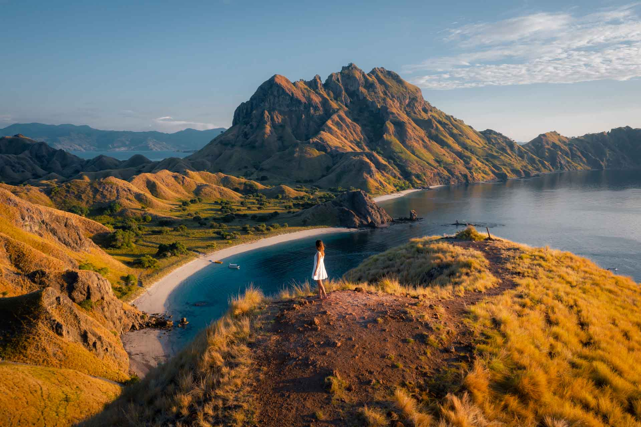
CONFIDENTIAL FORvAGENT RATE
REGULAR OPEN TRIP SAILING KOMODO EVERYDAY 2026

www.sailingkomodo.com

Friendly Customer Services : Call/Whatsapp
+6282332664599 with Ronald

SAILING KOMODO 3 DAYS 2 NIGHTS
(DEPARTURE EVERY FRIDAY & MONDAY GUARANTED - NO MINIMUM PAXS)

DAY 1 / TRANSFER IN – HALFDAY SAILING KOMODO TOUR (L,D)
Welcome in Meeting Point (Hotel / Airport of Labuan Bajo) at 10.00am - 11.00am. You will be pick up with our professional team to accompany you in Labuan Bajo harbor, then you may in boat that we have been prepare before. We will introduce you to all of the boat crew who’s will be serve you such as: boat captain and chef. After that sailing begin to visit Kelor Island which have a amazing for snorkeling and tracking to the hill or just enjoy the beauty beach and mangrove. Until end we will cruising to Kalong Island to wait the bats arrive also beautiful sunset. Free program and will be tie up and take a rest here. Stay on the boat.

DAY 2 / FULLDAY SAILING KOMODO TOUR (B,L,D)
Early morning we will be sailing to Padar Island which it will be much tracking. Satisfied in Padar we will continue to Long Beach (the largest pink beach) to play in beach, snorkeling and take a video documentation. Until end. Then next destination is Komodo Island. Here we will see the habitat of Dragon Lizard (Komodo) species with a ranger (tour guide specialist Komodo). Then our boat continue sailing to Manta Point to swim or snorkeling together with Manta Ray. Than you will be in Gusung Island or Taka Makassar to take a picture on the sea which it so pure and next sailing to the Gili Lawa (Laba). We will be sunset hunting and stay overnight.

DAY 3 / HALFDAY SAILING KOMODO TOUR – TRANSFER OUT (B,L)
Morning call to watch a sunrise in Siaba Island or Sebayur. Then we will be end of the sailing to Kanawa island. Until finished you will back to Labuan Bajo harbour. There you will be pick up with land transportation and drop you to the Drop Point (Hotel / Labuan Bajo Airport). Here tour finished with memorable with us.

HARGA NETT TO AGENT :
- STANDARD BOAT
SHARE CABIN (QUADSHARE) : IDR 2.000.000,-/pax (Publish IDR 2.300.000,-/pax)
PRIVATE CABIN (TWIN SHARE/COUPLE) : IDR 2.300.000,-/pax (Publish IDR 2.600.000,-/pax)

- SUPERIOR BOAT
SHARE CABIN (QUADSHARE) : IDR 2.300.000,-/pax (Publish IDR 2.600.000,-/pax)
PRIVATE CABIN (TWIN SHARE/COUPLE) : IDR 2.600.000,-/pax (Publish IDR 2.900.000,-/pax)

- PHINISI BOAT
SHARE CABIN (QUADSHARE) : IDR 2.800.000,-/pax *Toilet outside (Publish IDR 3.000.000,-/pax)
SHARE CABIN (QUADSHARE) : IDR 3.200.000,-/pax *Toilet inside (Publish IDR 3.400.000,-/pax)
PRIVATE CABIN (TWIN SHARE/COUPLE) : IDR 3.400.000,-/pax * Toilet inside (Publish IDR 3.800.000,-/pax)

*If you're a solo traveler, you'll be grouped with other participants in one room.
*Don't worry, we'll arrange room assignments based on gender, unless otherwise requested by the customer.

FACILITIES :
- Pick up service Hotel to Harbor
- Boat live on board during 3 days
- Speedboat (sekoci)
- Boat Captain , Boat Crew and Chef
- Tour Guide
- Accommodation in the boat. Cabin AC
- 7 x food during journey in the boat
- Coffee and tea un limited
- Snorkeling tolls
- 1x welcome snack
- Mineral water during tour
- First Kits
- Documentations (Darat DSLR/Mirrorless, Underwater and Drone)

TERM AND CONDITIONS :
- Price can be change if any change price of component which out of the untolerate standart
- Expense out of the component itinerary is a your responbility
- Tour schedule can be change any time it depedate on the climate
- Price not include for the optional tour, or object furthermore
- Price not include overbalance of fuel for unusuall pick up service
- Price not include yet : Air plane ticket, tipping guide, private necessary
- Price not include yet : entry Komodo National Park
- Price can be change any times dependant on the boat that you ordered

BOAT PHOTOS FOR 3D2N :
STANDARD BOAT
PADA IDI / ARHAM JAYA / NUSANTARA KARYA, ETC (according to availability)

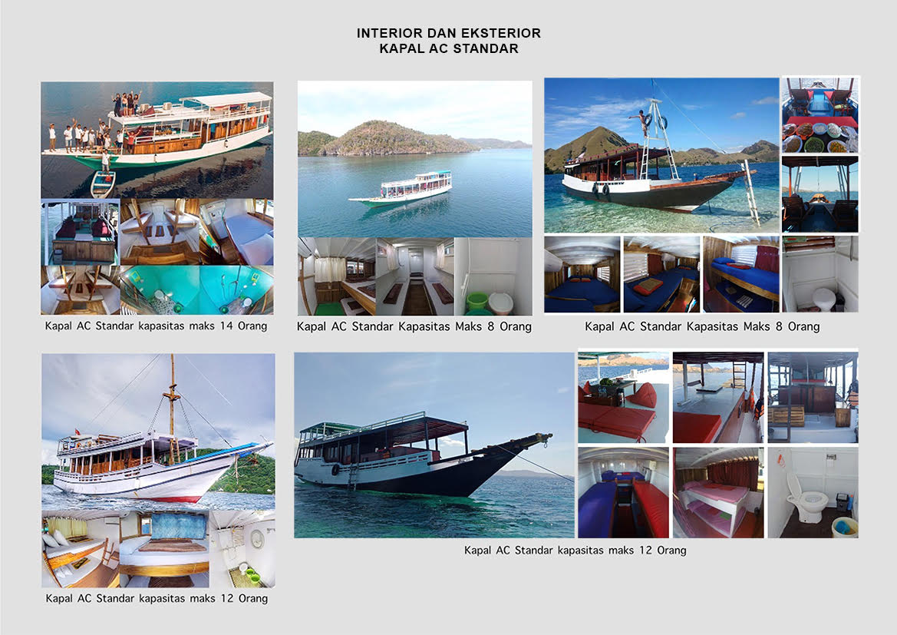

SUPERIOR BOAT
KING CIROX / DIANTARA / PRINCESS LALA / ETC (according to availability)
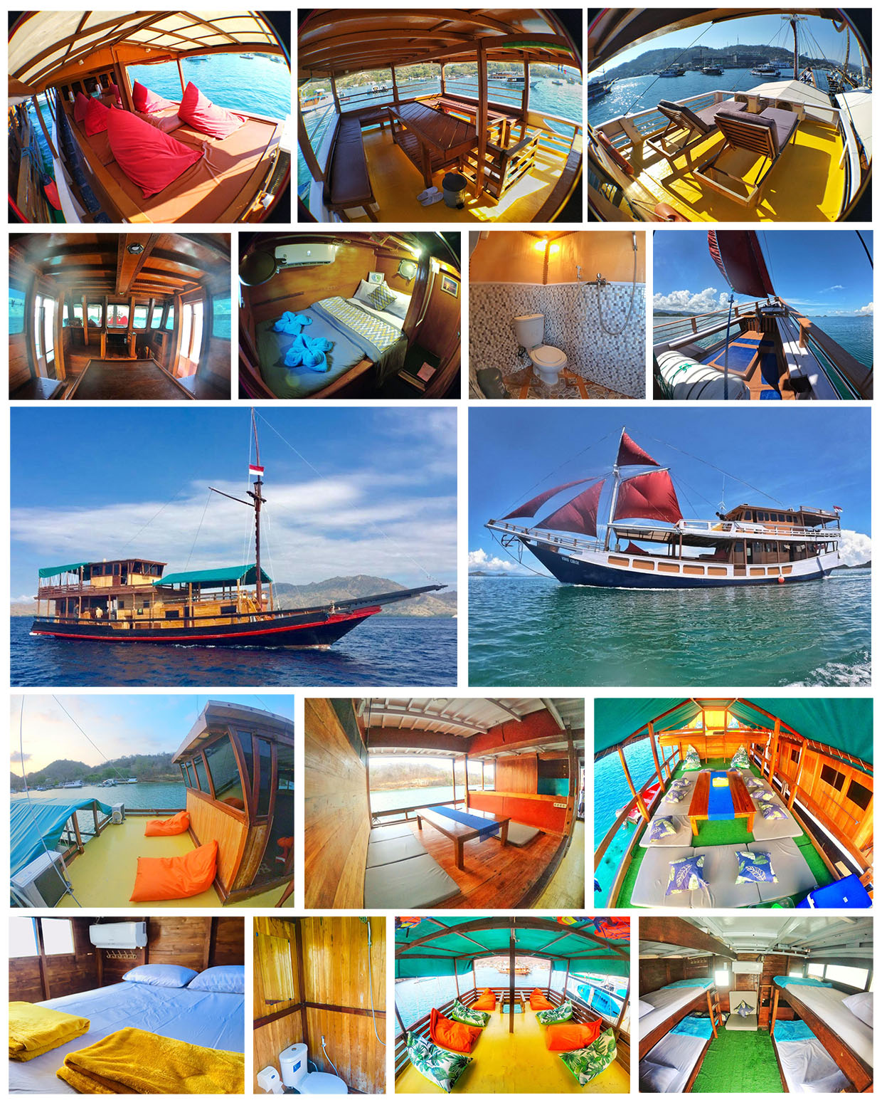

PHINISI BOAT
ATHIRA / MY MOON, ETC (according to availability)

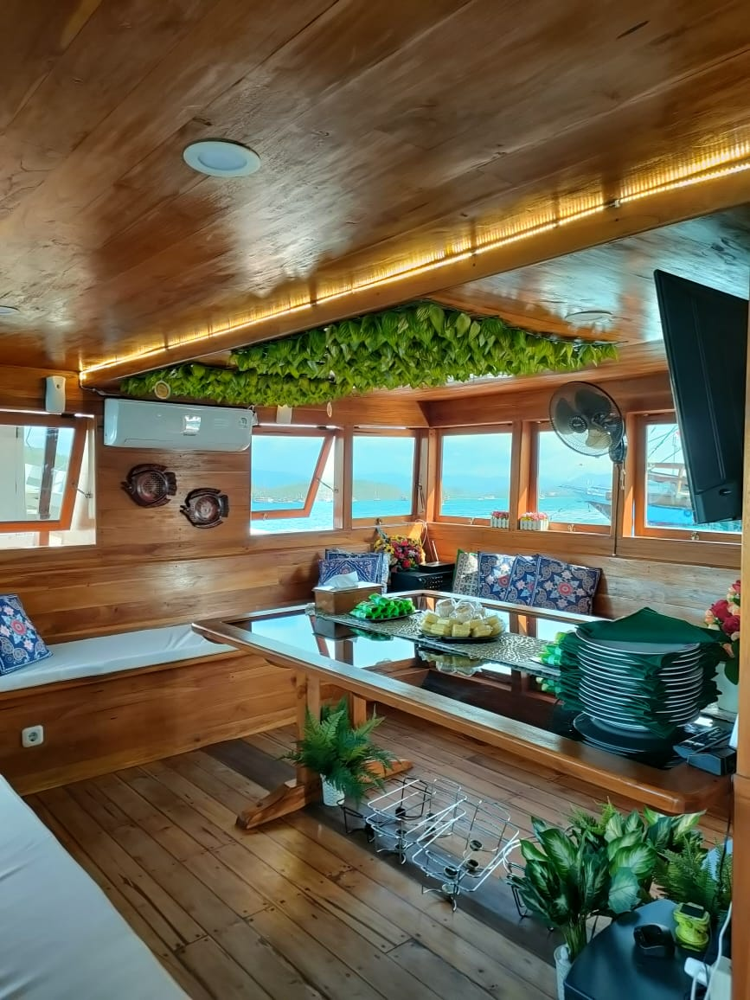
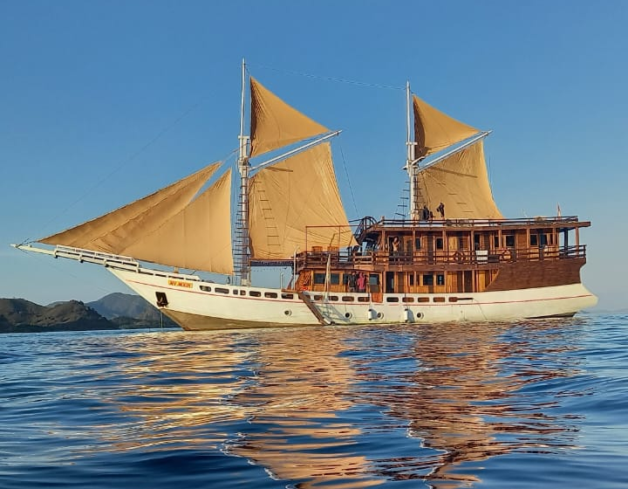

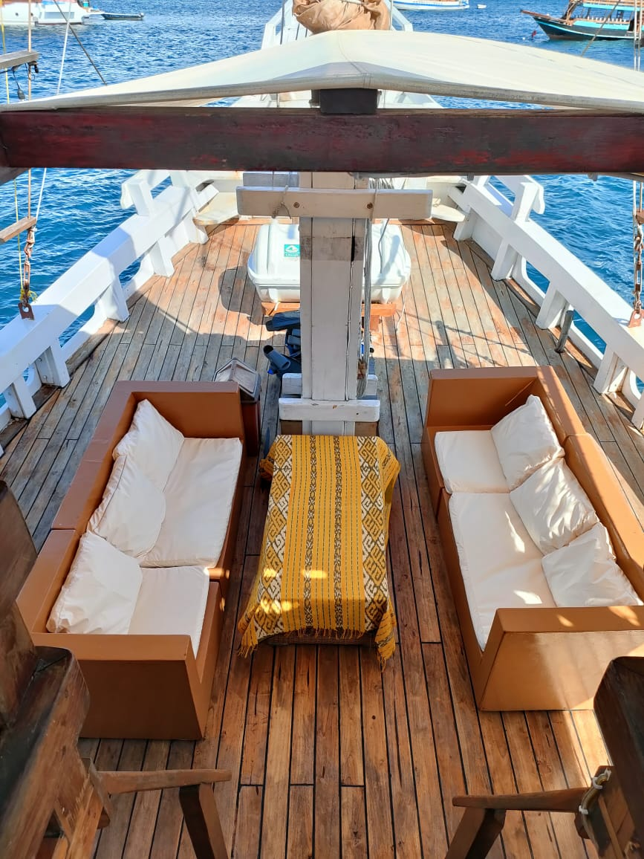

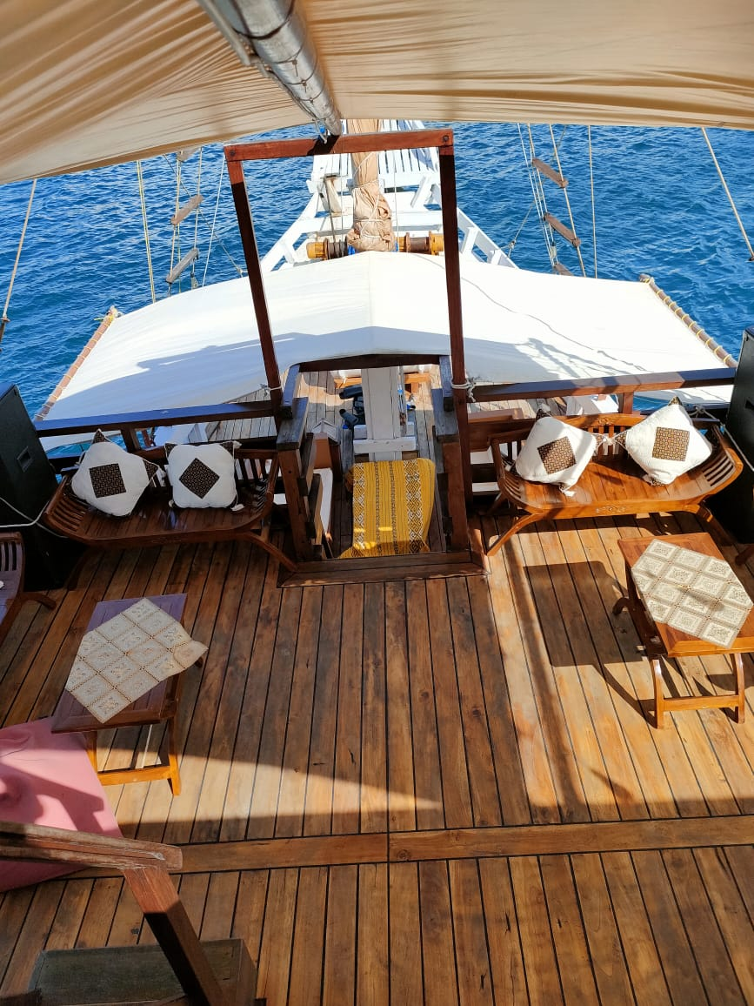

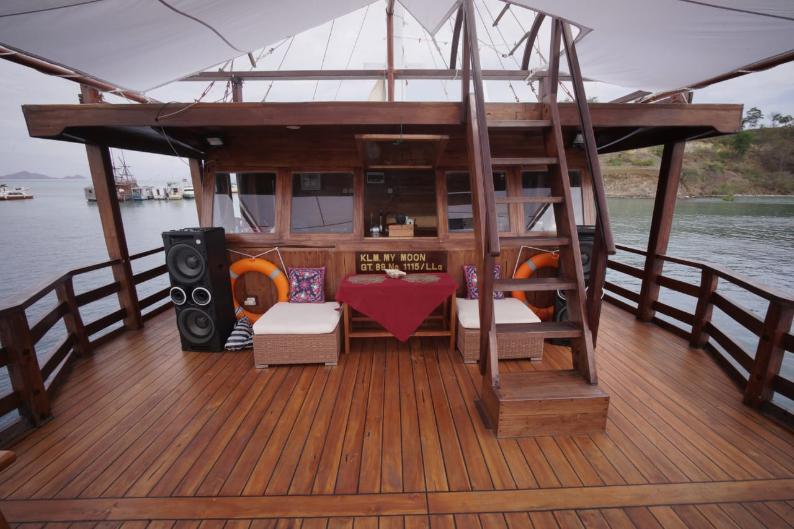

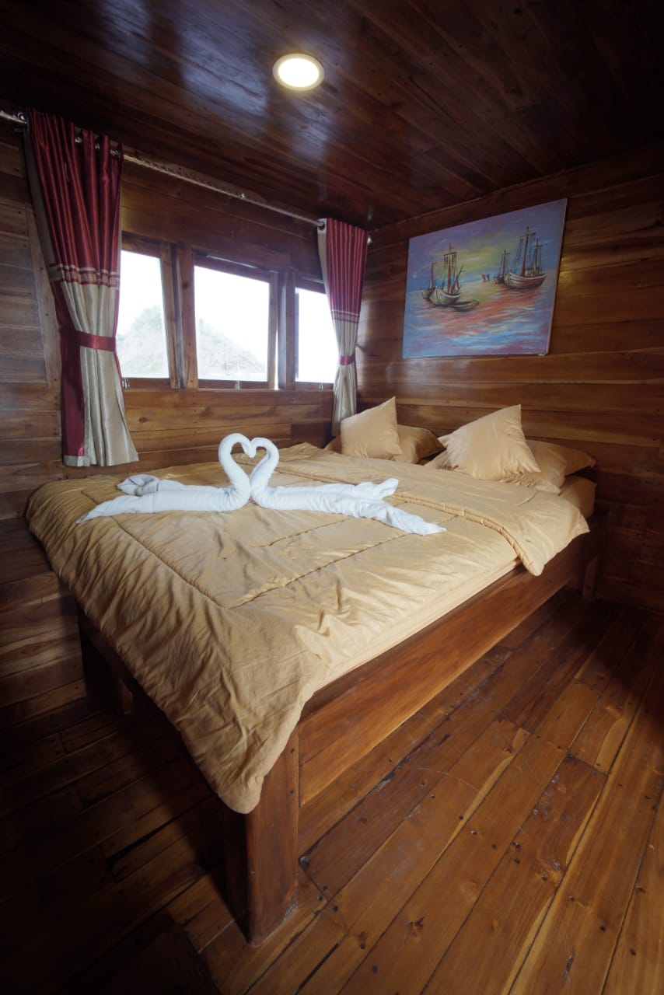
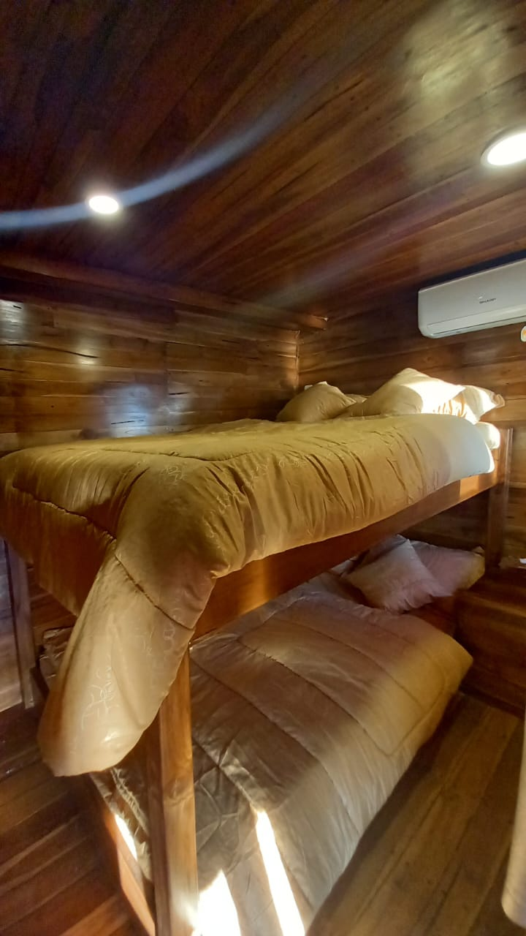

SAILING KOMODO 2 DAYS 1 NIGHT
(DEPARTURE EVERY DAY GUARANTED - NO MINIMUM PAXS)

DAY 1 / TRANSFER IN – FULLDAY SAILING KOMODO TOUR (L,D)
Welcome in Meeting Point (Your Labuan Bajo Hotel). You will be pick up in a hotel 08.00am – 09.00am and hospitality with our professional team so prepare to sail with boat which we have prepared. We will be begin a sailing activities. First we visit a Kelor Island for short trekking to enjoy the exotic place. After that we go to Manjerite for snorkeling program. Until end we will be sail to Kalong Island to wait bat arrive also sunset. Free program and will be tie up and take a rest here. Stay on the Boat.

DAY 2 / FULLDAY SAILING KOMODO TOUR – TRANSFER OUT (B,L)
Early morning we will be sailing to Padar Island which it will be much tracking. Satisfied in Padar we will be to Long Beach (the largest pink beach) to play in beach, snorkeling and take a video documentation. Until end. Next destination is Rinca island that you can enjoy also watch the Dragon Lizard habitat directly with accompany the rangers (Komodo Tour Guide). Then our boat continue sailing to Manta Point to swim or snorkeling together with Manta Ray. Than we will be end of the sailing to Kanawa island. After that you will be accompany to harbour and in there already transportation to accompany you to Drop point (Hotel in Labuan Bajo) 05.00pm – 06.00pm. Sail finished with memorable impression with us.

HARGA :
- SHARE CABIN (Quad Share/more)
PUBLISH : IDR 1.950.000,-/pax
CON-RATE : IDR 1.750.000,-/pax
- PRIVATE CABIN (Twin Share/Couple)
PUBLISH : IDR 2.150.000,-/pax
CON-RATE : IDR 1.950.000,-/pax

*If you're a solo traveler, you'll be grouped with other participants in one room.
*Don't worry, we'll arrange room assignments based on gender, unless otherwise requested by the customer.

FACILITIES :
- Pick up service Hotel to Harbor
- Boat live on board during 2 days (Share)
- Boat Captain , Boat Crew and Chef
- Tour Guide
- Accommodation in the boat. Cabin AC
- 4 x food during journey in the boat
- Coffee and tea unlimited
- Snorkeling tolls
- 1 x welcome snack
- Mineral water during tour
- First Aid Kits

TERM AND CONDITIONS :
- Price can be change if any change price of component which out of the untolerate standart
- Expense out of the component itinerary is a your responbility
- Tour schedule can be change any time it depedate on the climate
- Price not include for the optional tour, or object furthermore
- Price not include yet : Air plane ticket, tipping guide, private necessary and Komodo National Park Tickets
- Price can be change any times dependant on the boat that you ordered

Note: The Boat is RANDOM. Determination of the size of the ship according to the number of trip participants on that day.

SAILING KOMODO FULLDAY (ONE DAY TOUR)
(DEPARTURE EVERY DAY GUARANTED - NO MINIMUM PAXS)

DAY / FULLDAY SAILING KOMODO TOUR (L)
In the morning at 6am. We will be meet in Labuan Bajo Harbour to sailing. Your journey begin to visit Padar Island. After that we will be sail to Pink Beach. After sastified. You will be continue the journey toward one of theworld miracles such as Komodo Island. Until sastified look the komodo and take a pictures accompanied by the ranger (tour guide Komodo), you will be sailing again to the Manta Point or Kelor Island. Here you can snorkeling. After that you will be accompany to the Drop Point (Labuan Bajo harbour). Tour explorer Komodo islands finished with amazing impression with us.

PRICES :
PUBLISH : IDR 700.000,-/pax
CON-RATE : IDR 550.000,-/pax

FACILITIES :
- Open Deck Boat
- Boat Captain and Boat Crew
- Tour Guide
- 1 x food during journey in the boat
- Coffee, tea and snack
- Snorkeling tolls
- Mineral water during tour
- First Kits

TERM AND CONDITIONS :
- Price can be change if any change of price the component which out of the standart tolerate, to adjust a concept of journey and allocation of the tourist total
- Tour program can be change any times it dependent on the climate
- Price not include operational tour or object extra
- Price not include yet the ticket entry to Komodo National Park
- If any one need pick up service in hotel we can help with cheap price

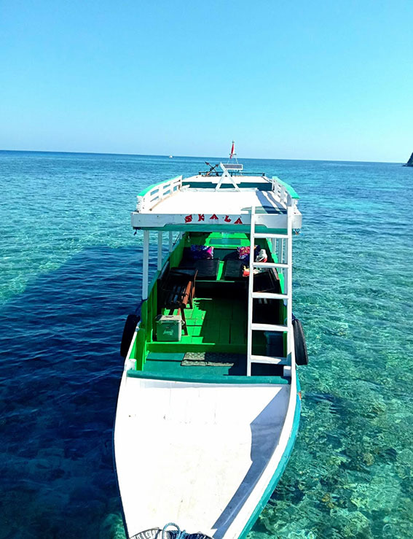
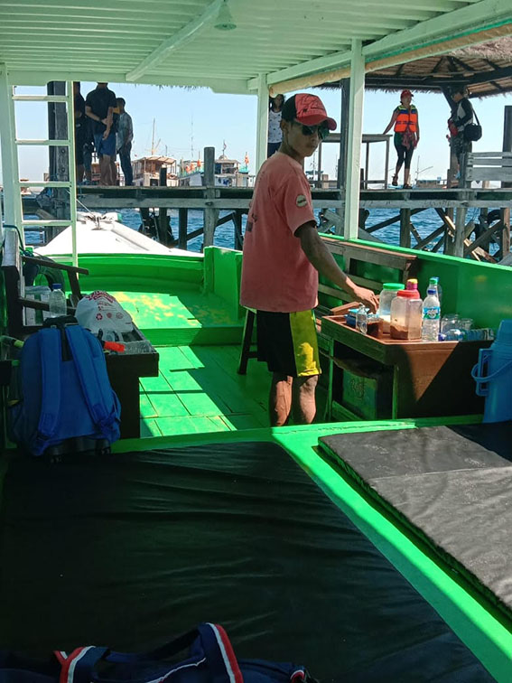
BOAT PHOTOSONEDAY TOUR :
OPEN DECK

SAILING KOMODO FULLDAY (ONE DAY TOUR by Speedboat)
(DEPARTURE EVERY DAY GUARANTED - NO MINIMUM PAXS)

DAY / FULLDAY SAILING KOMODO TOUR (L)
In the morning at 6 a clock. We will pick up you from Meeting Point (Your Hotel) then be meet in Labuan Bajo Harbor to sailing. Your journey begin to visitPadar island. After that you will be continue the journey toward one of the world miracles Komodo island. Then we will be sail to Pink Beach.
Will be sailing again to the Taka Makassar. Then to Manta point. Here you can snorkeling and Siaba Island. After that you will be accompany to the Harbour first then Drop Point (Your Hotel). Tour explorer Komodo islands finished with amazing impression with us. *Tour will be finish 05.00 pm

PRICES :
PUBLISH : IDR 1.300.000,-/pax
CON-RATE : IDR 1.000.000,-/pax

FACILITIES :
- Return Transfer Hotel – Harbour
- Exclusive Speedboat
- Boat Captain and Boat Crew
- Tour Guide
- 1 x food during journey in the boat
- Coffee, tea and snack
- Snorkeling tolls
- Mineral water during tour
- First Kits

TERM AND CONDITIONS :
- Price can be change if any change of price the component which out of the standart tolerate, to adjust a concept of journey and allocation of the tourist total
- Tour program can be change any times it dependent on the climate
- Price not include operational tour or object extra
- Price not include yet the tickets in Komodo National Park
- If any one need pick up service in hotel we can help with cheap price
- The size of the ship used depends on the number of participants departing that day.

BOAT PHOTOS ONEDAY TOUR :
SPEEDBOAT
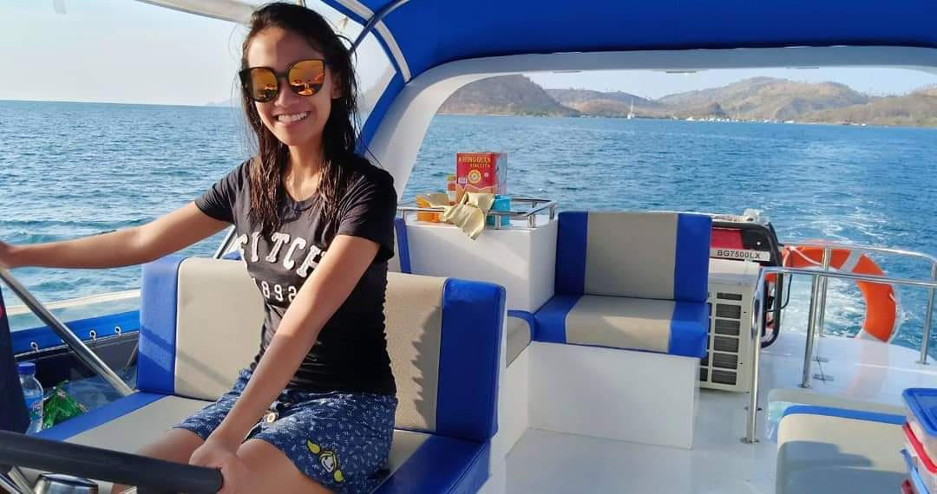
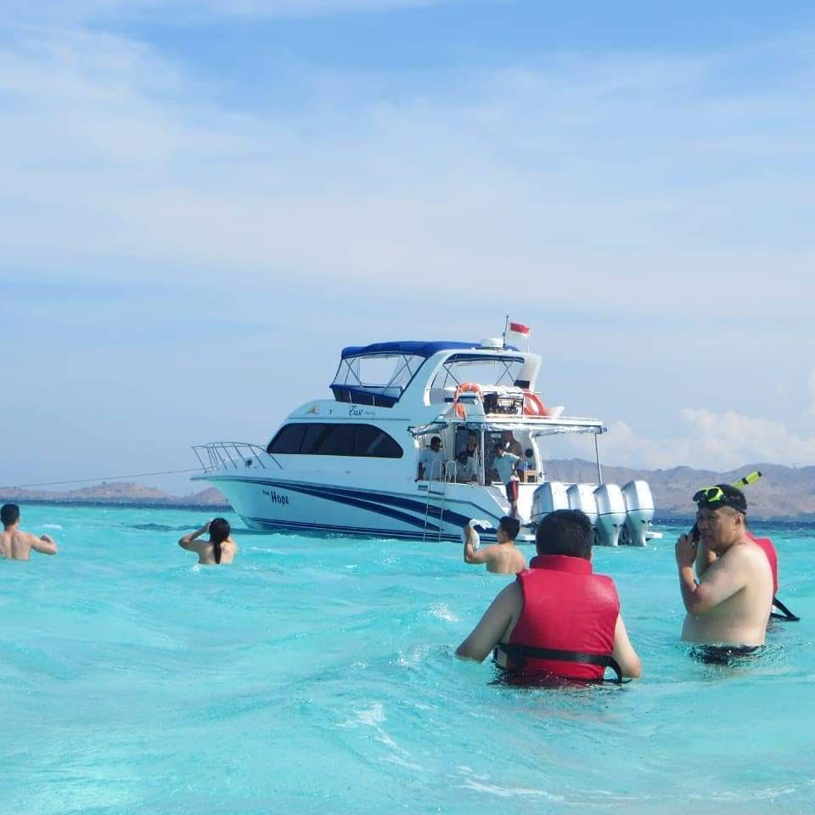
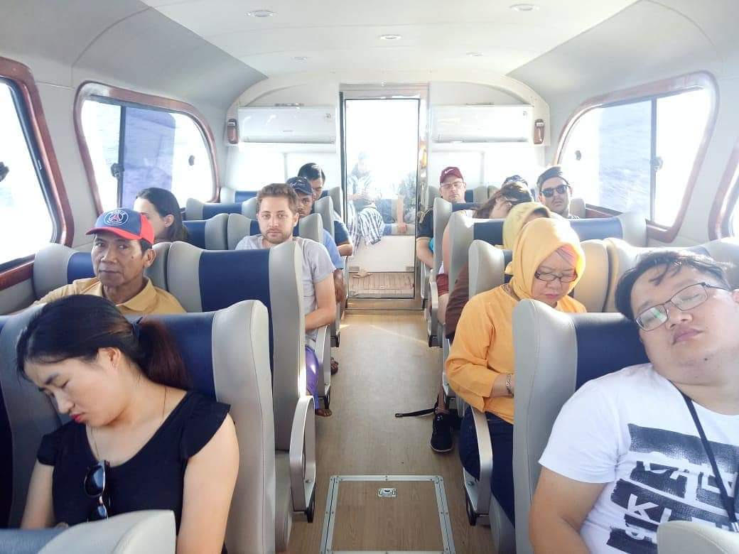

SUNSET TRIP (HALFDAY LOCAL BOAT)
DEPARTURE EVERY DAY GUARANTED - NO MINIMUM PAXS ( START 02.00 PM – FINISH 07.00 PM )

DAY / HALFDAY SAILING KOMODO TOUR (-)
At 2 p.m., our professional team will pick you up at the meeting point (hotel/airport/your location in Labuan Bajo) and proceed to the harbour. Your first journey will visit to Kelor Island. We'll begin trekking and relax on the island, admiring the beauty of Menjaga Hills from above. Afterward, we'll head to Manjerite. Here, you'll be free to snorkel, accompanied by a tour guide. Once satisfied, you'll continue your trip to Kalong Island to enjoy the sunset, accompanied by millions of flying bats.
Upon completion, you will be escorted back to the Drop Point (Hotel Labuan Bajo). The Sunset Trip concludes impressively with us :). *This trip will conclude approximately at 7 p.m.

HARGA:
PUBLISH : IDR 550.000,-/pax
CON-RATE : IDR 400.000,-/pax

FACILITIES :
- Return Transfer Hotel – Harbour
- Open Deck Boat
- Boat Captain and Boat Crew
- Tour Guide
- 1 x food during journey in the boat
- Coffee, tea and snack
- Snorkeling tolls
- Mineral water during tour
- First Kits

TERM AND CONDITIONS :
- Tour program can be change any times it dependent on the climate
- Price not include yet the tickets entry to Island *Can pay by yourself

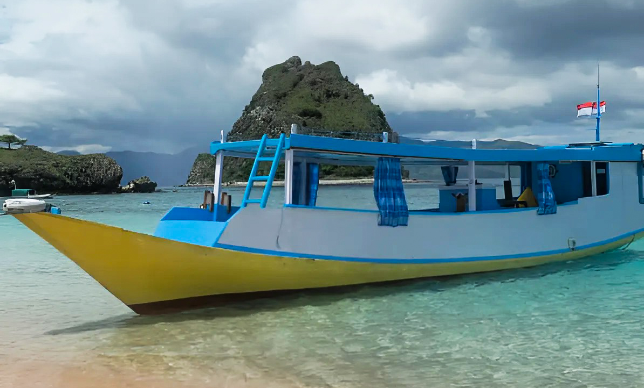
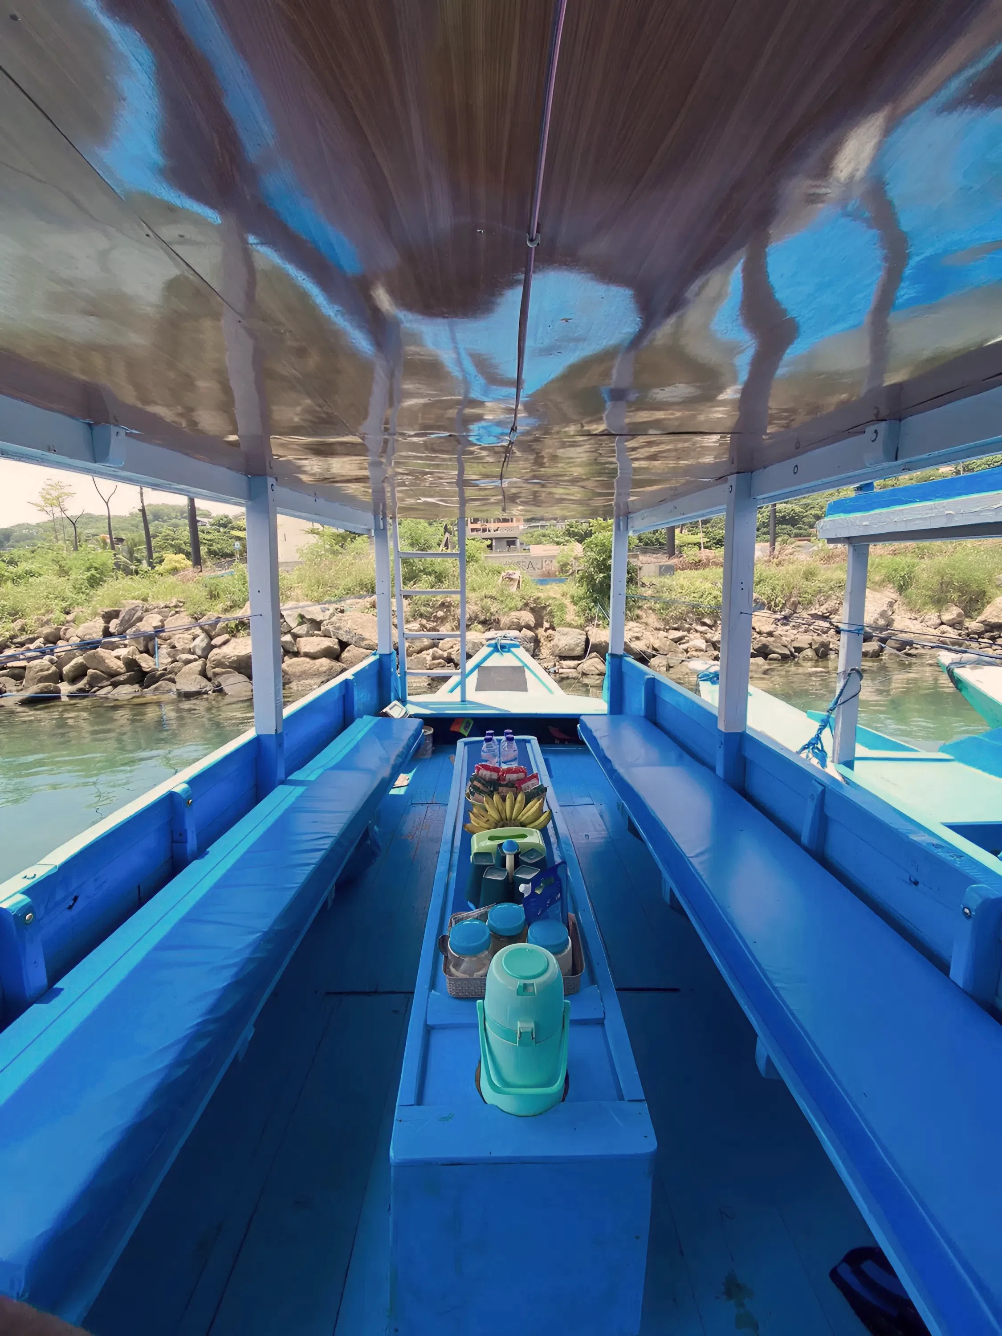
BOAT PHOTOS :

